|  |  |
| --- | --- |
| **Website :** [**www.dvsdegreecollege.org.**](http://www.dvsdegreecollege.org/) **Off : 08182-278455**  **Email :** [**principal.dvscollege@gmail.com**](mailto:principal.dvscollege@gmail.com) **Fax : 08182-401592** | |
|  | **D.V.S. College of Arts & Science, Shimoga**  (Permanently Affiliated to Kuvempu University)  (Accredited with **“A”** grade from National Assessment & Accreditation Council)  Sir M.V.Road, Post Box No.81, Shimoga-577201, Karnataka State. |

Vision & Mission

**Engaging, Learning, Transforming Since 1966**

DVS College of Arts & Science, Shivamogga a first Grade College was opened on the 1st of July 1966. This institution of Excellence in the field of higher education in Malnad region has reached milestone of 50 years.

**VISION:**

To strive to become an institution of excellence in the field of higher education, to provide value-based, career-oriented education to ensure integrated development of human potential for the service of mankind**.**

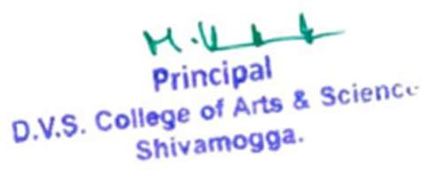

**MISSION:**

Our mission is to realize our vision through,

* Promoting and facilitating education in conformity with the statutory and regulatory requirements.
* Planning and establishing necessary infrastructure and learning resources.
* Supporting faculty development programmes and continuing education programs.
* Initiating and sustaining meaningful research activity
* Promoting institution–industry interaction and collaboration at all levels.
* Ensuring harmonious and mutually rewarding relationships among all stakeholders of the institution.